WORKSHEET
NAME-SURNAME: |  | NUMBER: | P:

A)Write their Turkish meanings. (anlamlarını yazınız)
aggressive :……………………………
bald :……………………………
curly :……………………………
friendly :……………………………
handsome :……………………………
helpful :……………………………
overweight :……………………………
punctual :……………………………
selfish :……………………………
slim :……………………………
B) Choose the correct picture.(doğru resmi seçiniz)
a) He is bald. (……)
b) He is good-looking. (……)
c) He has a moustache. (……)
d) He is wearing glasses. (……)
e) He is over weight (……)
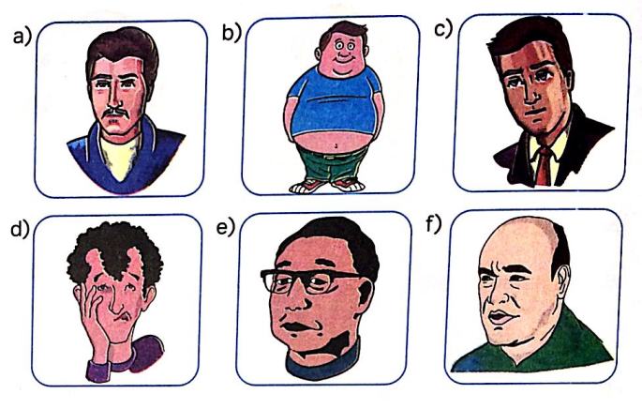

c) Circle the correct word. (doğru kelimeyi daire içine alınız)
- My brother is 16 years old. My sister 12 years old. My brother is older/slimmerthan my sister.
- Ahmet always studies his lesson. Can always plays soccer. Ahmet is more beautiful / more hardworkingthan Can.
- My mother is 1.60 cm. My father is 1.70 cm. My father is shorter/tallerthan my mother.
- Engin usually stays at home and watches TV. Berk likes making friends. Berk is more outgoing/stingierthan Engin.
D) Write the words in the correct column. (sıfatları doğru yerlerine yazın)

clumsy | forgetful | friendly | lazy | punctual | selfish

PositiveFeatures | Negative Features
E) Match. (Eşleştirin)
1. | What does she look like?
2. | What is she like?
3. | What is he like?
4. | What does he look like?
 |  | Murat is a generous and punctual person.
 |  | Zeynep is a beautiful girl with curly hair and hazel eyes.
 |  | Mehmet is tall and slim. He has got blonde hair.
 |  | Ayşe is very clever and social.

F. Write down the Turkish meanings of the words. (anlamlarını yazınız.)

a.)Honest:……………………. e.) Move:………………………..

b.)Famous:…………………….. f.) Get Married:………………………….

c.) Success:……………………… g.) Die:………………………….
d.) Medal:…………………. h.) Grow up:……………………..
G.Match the given adjectives with the pictures. (resmin altına doğru kelimeyi yazınız )
punctual – tall – shy – handsome – stubborn – generous – hardworking – fat
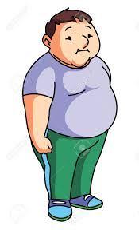 | 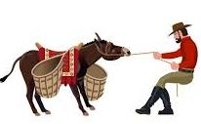 | 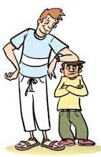
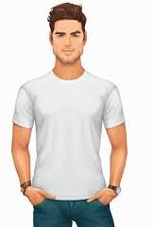

H. Complete the sentences according to the comparative types. (comparative hallerini yazınız)
- She is ………………..……………………..(beautiful) than her sister.
- Lucy is ........................................ (slim) than Sarah
- My toy car is ………..…………………………….(expensive) than your toy car.
- My sister is ........................................ (tall) than me.
- Antalya is …………………………..……….(hot) than Erzurum.
- My mother is ........................................ (generous) than my father.

I. WRITE THE SPORTS( spor türlerini doğru resmin altına yazınız)
ARCHERY / CYCLING/WRESTLING/VOLLEYBALL / SKIING

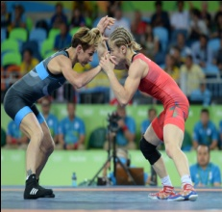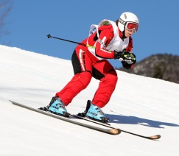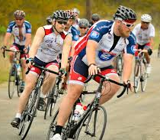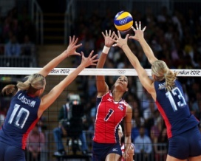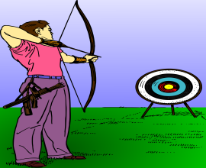
Hello! My name is Sally. I am from France. I am 13 years old. I am a student. I like sports very much. I am a sporty girl. I usually play football. I swim once a week. I run twice a day. I cycle to school three times a week. In winter, I go skiing once a year. I do karate twice a week. I sometimes rollerblade after school.

J. Answer to the questions according to the text. (okuma parçasına göre soruları cevaplayınız)

- How often does she swim? ………………………………………………………………………………….
- How often does she run? ………………………………………………………………………………….
- How often does she rollerblade? ……………………………………………………………………………….
- How often does she play football? ………………………………………………………………………………

K. Write the sport equipments under the pictures ( kelimeleri doğru resmin altına yazınız )
BALL / HELMET / RACKET / GOOGLES / GLOVES /

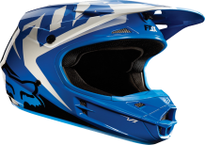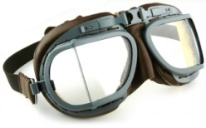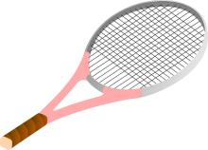
…………..….. ……………… ……………… …………….. ………………………

L. Categorize words as physical appearance or personality ( kelimeleri uygun bölüme yazınız)
SLIM / HELPFUL / OUTGOING / OVERWEIGHT /PUNCTUAL / HANDSOME / TALL / EASYGOING
PERSONALITY | PHYSICAL APPEARANCE
https://www.sorubak.com

