WORKSHEET FOR EXAM
NAME SURNAME: NO: GRADE:6/__
A- Put the dialogue in correct order ( Diyaloğu anlamlı olacak şekilde sıraya diziniz)
1-
2-
3-
4-
5-

a- Sure! Would you like to drink something cold ?
b- Ok! Maybe ,but I enjoy eating fried egg
c- Can I have some sausages, please?
d- No thanks, I prefer drinking hot drinks. I want to have a couple of tea with milk.
e- Sorry sir, it’s all gone .Do you want some pastrami with scrambled egg?

B-Circle the correct words (Anlam bütünlüğüne göre doğru kelimeyi yuvarlak içine alınız?

My day starts at 7:30 a.m. I usually have breakfast with my family. At breakfast there are (1)………………foods. We have olives, cheese, jam and bagels. At school I prefer eating (2)………………………at lunch in school canteen because it is nutritious and healthy. After my school finishes, I meet with my friends at Güneş Cafe and drink orange juice because there is (3)……………..in it. In the evenings, I’m not(4)…………………….and I don’t eat any foods. I hate junk foods. What about you? Do you eat (5)…………………….? I think they are not healthy.
1- nutritious -- unhealthy – fast foods
2- sausages – sweets – vegetables
3- yummy – protein – ingredient
4- hungry – thirsty – full
5- junk food – yummy -- healthy

C)MATCH THE TIME WITH THE CORRECT CLOCK (eşleştir)

- …D…… It’s eleven o’clock. A. 11:05
- ……… It’s half past eleven. B. 11:45
- ……… It’s quarter to twelve. C. 12:15
- ……… It’s quarter past twelve. D. 11:00
- ……… It’s five past eleven. E. 11:30
- ……… It’s a quarter past twelve. F. 12:15
D)WRITE THE TIME WITH NUMBERS (saati yaz)

- It’s half past nine : 0. 09:30
- It’s a quarter past two : 1. …………….
- It’s a quarter to five : 2. …………….
- It’s five o’clock : 3. …………….
- It’s quarter to six : 4. …………….
E)WRITE THE TIME WITH LETTERS(saati yaz)
- 08:30 : 0. It’s half past eight.
- 07:15 :
- 09:30 :
- 11:45 :
- 12:00 :
F)WRITE THE CORRECT PHRASES UNDER THE PICTURES (doğru resmin altına yaz)
Finish all the homework | Wake up | Have dinner | Go to bed | Get dressed

 |  | 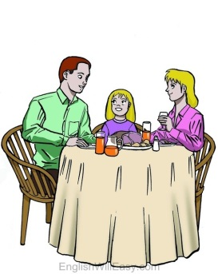 |  | 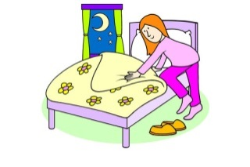
……………………….. | ……………………….. | ……………………….. | ……………………….. | ………………………..

G.WRITE THE CORRECT WORDS UNDER THE CORRECT PISTURES (KELİMEYİ DOĞRU RESMİN ALTINA YAZ)
Bread | Cheese | Egg | Olive | Pancake

 | 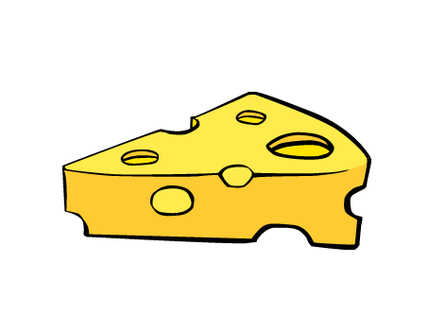 |  | 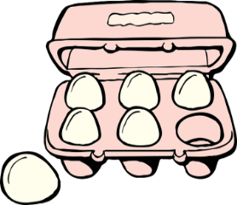 | 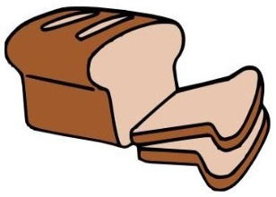
……………………….. | ……………………….. | ……………………….. | ……………………….. | ………………………..

H. MAKE SENTENCES ACCORDING TO THE TABLE AS IN THE EXAMPLE (ÖRNEKTEKİ GİBİ CÜMLE KUR)
 | 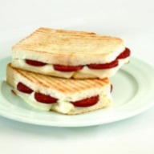 | 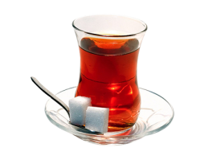
Selen |  | X |  | X
Kaan |  |  | X | X
Mert | X |  |  | X
Sevim | X | X |  | 
Neşe |  | X | X | 
- Selen likes toast and omelette, but she doesn’t like tea and fruit juice.
- Kaan ……………………………………………………………………………………………………………………………
- ……………………………………………………………………………………………………………………………………
- ……………………………………………………………………………………………………………………………………
- ……………………………………………………………………………………………………………………………………
I. COMPLETE THE DIALOGUE WITH THE SENTENCES GIVEN BELOW (cümlelerle diyaloğu doldur)
Enjoy it! | It’s my favourite. | Sorry, it’s all finished. | What do we have for breakfast?
MOM : Alex! It’s breakfast time! Come here, honey!
ALEX : OK, mom! I’m coming. ………………………………………………….…………..
MOM : We have cheese, olives, tomatoes and eggs.
ALEX : Do we have jam?
MOM : ………………………………..………… .Do you want honey?
ALEX : Oh, yummy. ……………………………….……………. . I like it.
MOM : ……………………………………………………………

İ-Match the words with their Turkish meaning( Kelimeleri Türkçe anlamları ile eşleştiriniz)

1- Delicious | 1- | a-Tadını çıkart
2- Pancake | 2- | b- Lezzetli
3- It’s all gone | 3- | c- Kek
4- Enjoy it | 4- | d- Hepsi bitti
5- Muffin | 5- | e- Krep,gözleme

Hi! My name is Emre. I wake up early on weekdays. It is 7:00a.m. After I brush my teeth and wash my face, I usually have my breakfast at 7:30 a.m. I leave home after feeding my little cat. I walk to school with my friend, Nazım. We attend folk dance course after school, we enjoy traditional dance. When I come home I always take a nap from 16:00 to 18:00 p.m. I prefer doing homework but I don’t usually do cleaning and do ironing. At 23:00, I go to sleep but before sleeping I write my diary about beautiful day.
J-Read the text and circle True or False ( Paragrafı okuyunuz ve doğru ise ‘T’ yada yanlış ise ‘F’ şıkkını seçiniz )
1- He gets up early at weekends T / F
2-He likes doing run errands T/ F
3-He sleeps hours a day when he comes back from school T / F
4-He doesn’t take care of his cat T / F
5-He goes to bed before 12 p.m. T/ F
K-Match the words with the correct pictures( Kelimeleri doğru resim ile eşleştiriniz)
1- visit grandparents 2- have a rest 3- ride a bike 4- take a shower 5- shopping


 

