A) Match the words with the pictures. (RESİMLERLE KELİMELERİ EŞLEŞTİRİNİZ)
1) English 2) PhysicalEducation 3) Science 4) Maths 5) Art 6)Music

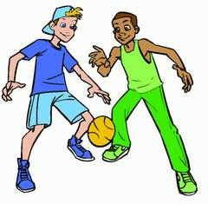
…………………………………………………………………………………………………………………………………………………………………….
B: Match the words with their meanings.(KELİMELERİ ANLAMLARIYLA EŞLEŞTİRİNİZ)
a. hafta sonu
b. cami
c. havuz
d. eczane
e. manav
f. öğrenmek
g. hastane
h. otobüs durağı
i. kırtasiye
j. deney
1. learn (__)
2. experiment (__)
3. weekend (__)
4.stationary (__)
5. bus stop (__)
6. greengrocer (__)
7. pool (__)
8. mosque (__)
9. pharmacy (__)
10. hospital (__)

C)Fill in the blanks with the words in thebox(boşlukları kutudaki kelimelerle doldur)
on – nextto – in front of – in – under - behind

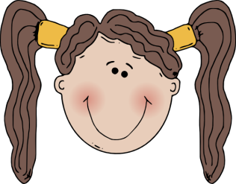
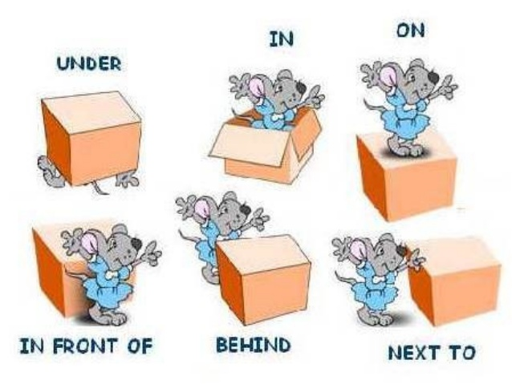

D) Complete the table according to the speechbubble.(konuşma balonuna göre doldur)
Name
Age
Country
Nationality
Languages
Favouritelessons
Likes
Dislikes
Hello!
My name is Alfred. I am 13 yearsold. I am from Germany and I am German. I speak English andGermanlanguages. My favouritelessonsare Music and P.E. He likes Music and P.E. but he doesn’tlikeMathsclass.

E) Matchthecountrieswiththenationalities.(ülke ve milliyetleri eşleştir)
Country | Nationality
1)Turkey | _____ German
2) Spain | _____ English
3) France | _____ French
4) Germany | _____ Japanese
5) Italy | _____ Spanish
6) England | _____ Italian
7) Japan | _____ Turkish

F)Look at the map and fill in the blanks. (haritaya bak ve boşlukları doldur)
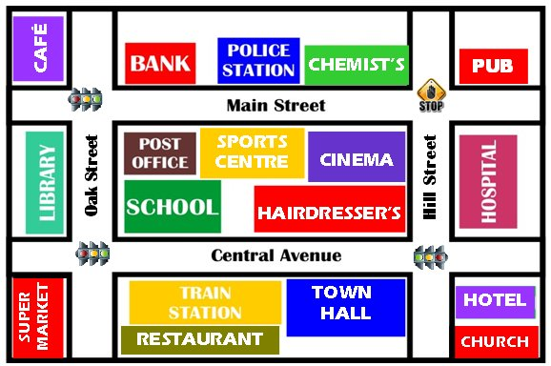
A: Excuseme. How can I gotothepolicestation?
B: Go ________ ahead. ______ thesecond _______. It is on your _______, nexttothe __________.

Youare here.

G)COMPLETE THE DIALOGUE WITH THE CORRECT SENTENCES GIVEN BELOW (cümleleri boşluklara yazalım)
Hi | I’m from Turkey | Nice to meet you, too
My name is Can | I speak Turkish and English | I’m twelve years old

JOHN : Hello!
CAN : Hi!
JOHN : I’m John. What’s your name?
CAN :……………………………………………………….
JOHN : I’m from Canada. Where are you from?
CAN : ……………………………………………………….
JOHN : I’m eleven years old. How old are you?
CAN :…………………………………………………………
JOHN : I speak English. How many languages do you speak?
CAN : Two. ……………………………………………………
JOHN : Nice to meet you.
CAN :…………………………………………………………….

H)ANSWER THE QUESTIONS ACCORDING TO THE TIMETABLE(çizelgeye gore cevapla)
MONDAY | TUESDAY | WEDNESDAY | THURSDAY | FRIDAY
English | Turkish | I.T. | Social Studies | Turkish
English | Turkish | I.T. | Social Studies | Turkish
Maths | P.E. | Science | Art | Music
Maths | P.E. | Science | Drama | English

- When’s music? - It’s on Friday.
- Which classes do you have on Monday? - I have double English and double Maths.
- When’s P.E.? - :……………………………………………………….
- When’s English ? - :……………………………………………………….
- Which classes do you have on Tuesday ? - :……………………………………………………….
- Which classes do you have on Friday ? - :……………………………………………………….
- How many classes do you have in a day? - :……………………………………………………….

I)COMPLETE THE SENTENCES WITH THE GIVEN PREPOSITIONS OF PLACE BELOW. (cümleleri verilen kelimelerle doldur)
on | in | behind | next to | between | In front of
WHERE IS THE DOG?
0. The dog is in the box. | 1. The dog is …………………………. the box. | 2. The dog is ………………………….the box.
3. The dog is ………………………….the box. | 4. The dog is ………………………….the boxes. | 5. The dog is ………………………….the box.

J)COMPLETE THE DIALOGUE WITH THE GIVEN PHRASES BELOW. (diyaloğu verilen ifadelerle doldur)
Where’s the | Thank you very much | straight ahead | the main street | The police station
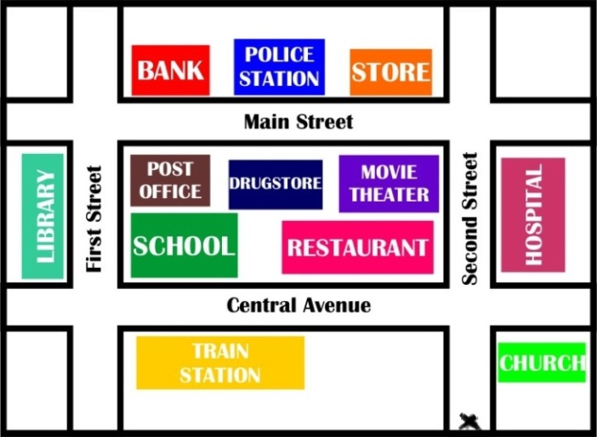
SUE :Excuseme, …………………….……….police station?
MAN :Go …………………….………..on the second street
andthen turnleft into……………….…………………………...
………………………………………...is between the bank and
the store.
SUE :…………………………………………
MAN :You’re welcome.

